

Apple ESCI Website Maintenance
Quick Reference Guide

Overview
This document introduces you to the process for updating content or page structure using the Drupal 9 authoring tool. The guide covers just the basics of accessing the system and making simple changes. You will find more detailed, searchable documentation on how to use Drupal at https://www.drupal.org/docs.

Login
To edit using Drupal, you first need to log in:
1. Go to: https://esci-uat.apple.com/user/login
2. Username: apple_admin
3. Password: ESCI-admin-!976

Activating the Content Editor
The site utilizes the Drupal Layout Builder, which provides tools to edit and adjust the layout of a page. The Layout Build is activated via the Layout button at the top of each page:
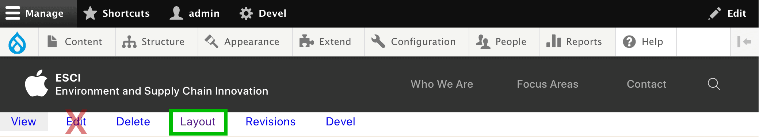
Note that you will not use the Edit button like with earlier versions of Drupal. Once in the Layout Builder there are a few key elements to become familiar with:
- Sections: Layouts are organized into sections which typically represent a row in the layout for like-items. Click the +Add section buttons to add a new section. There are three types of sections to choose from:
  - ESCI Hero: A custom styled row that can handle a full width image, video, headers, and a call-to-action button.
  - ESCI Tiles: A custom styled row for the various tile styles used throughout the site.
  - One to Four Column: A row for freeform content in the number of columns selected.
- Blocks: Blocks are chunks of content. There can generally be an unlimited number of blocks within a section. Click the +Add block buttons to add a new block, or drag an existing block to it’s desired place in the layout among other blocks and sections. When creating new blocks, click +Create custom block at the top of the configuration panel, and choose one of these block types:
  - ESCI Hero: For use in an ESCI Hero section, this block provides the settings for an image, video, headers, and a call-to-action button.
  - ESCI Tile: For use in an ESCI Tiles section, this block creates a single tile with settings for a title, image, text, and a link.
  - Basic Block: For use in a freeform column section, this block provides a text editor.
- Configuration: The configuration panel is where all settings and content are defined for sections and blocks.
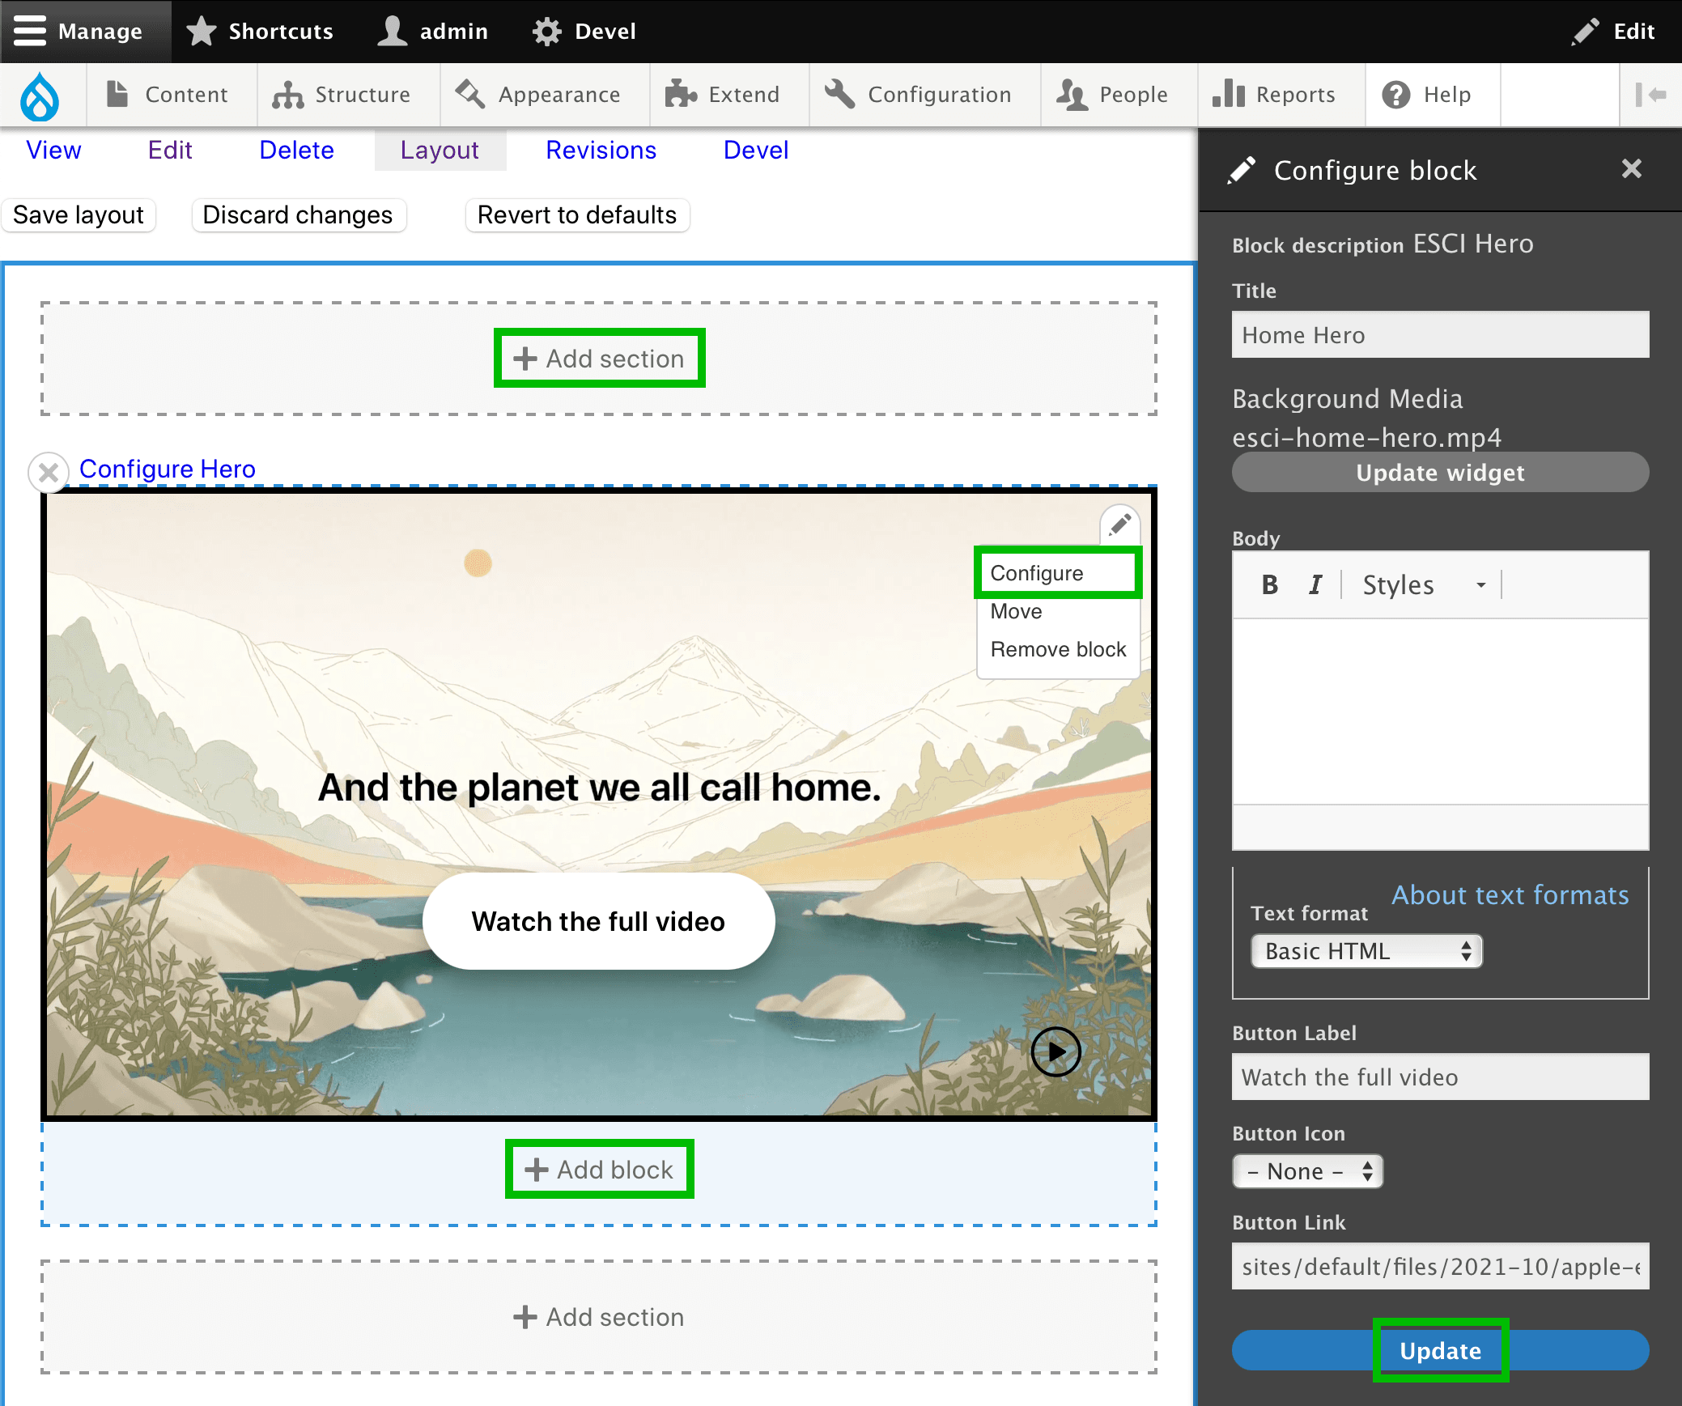

Editing Content
All editing is done in the configuration panel which can be opened by clicking the Configure Section links above each section, or by rolling over a block, clicking the Pencil Icon in the top right of the block, and choosing Configure. When you are done editing, click the Update button at the bottom of the panel.
Here is a list of all of the settings and their options:
- General: These settings apply to several sections and blocks:
  - Administrative label or Title: A required field that labels the element in the layout builder. It is only to assist in knowing the intent for each element while editing, and is usually not displayed for end-users (exceptions noted below).
  - Show Section Title or Display Title: will display the Administrative label or Title field as a header on screen.
  - Background Color: A selection of predefined backgrounds, currently consisting of brand-color gradients that either go left-to-right or right-to-left.
  - One to Four Column: A row for freeform content in the number of columns selected.
- Sections:
  - ESCI Hero:
    - Vertical Layout: Aligns text and buttons toward the top or bottom of the block, or evenly spaces them.
    - Width: Determines whether the block spans the full width of the window, or is constrained to the content area.
  - ESCI Tiles:
    - Tile Layout:
      - Generic Grid: For use with basic text blocks, displayed in a grid.
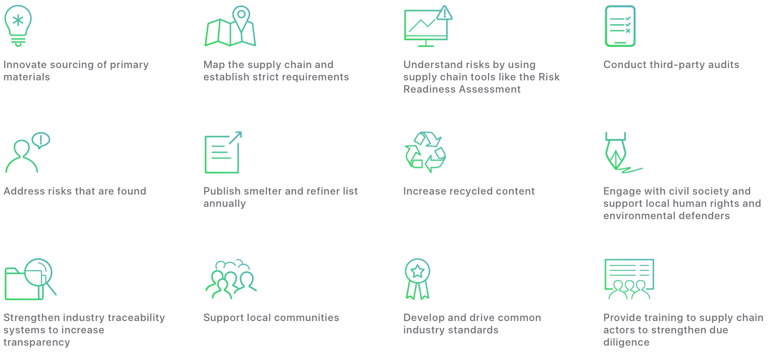
      - Icon Tiles: Used to style tiles over a background with an icon and.

      - Image Tiles: Used for tiles that have an image and text.
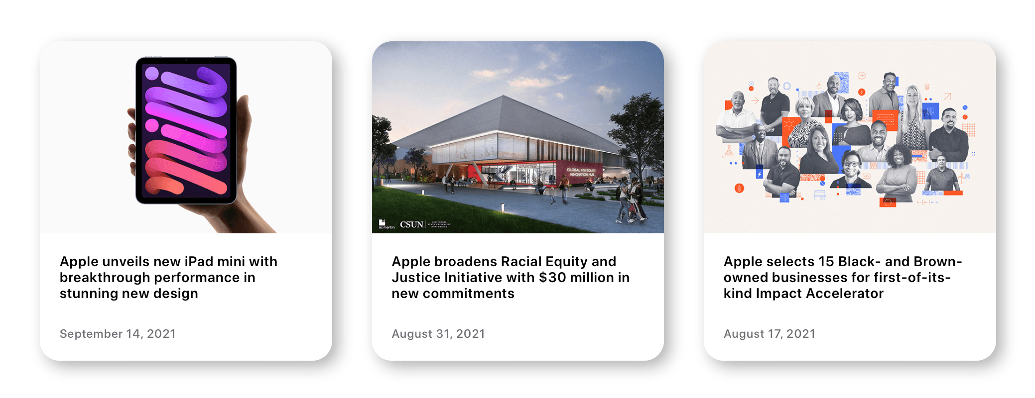
      - Stat Tiles: Used for rows of tiles that show a large stat with details.
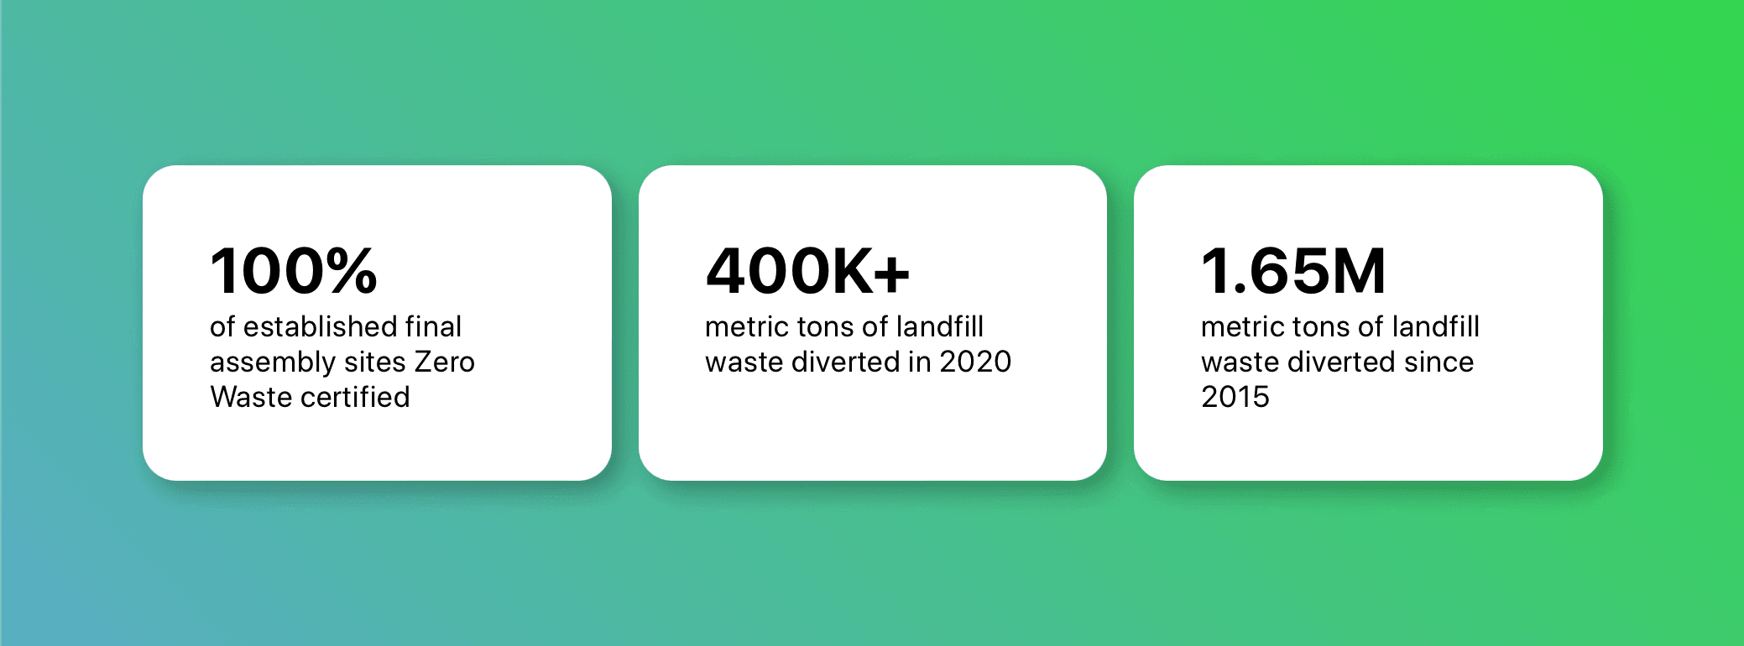
      - Joined Tiles: A specific style that looks more like a single tile with multiple columns.
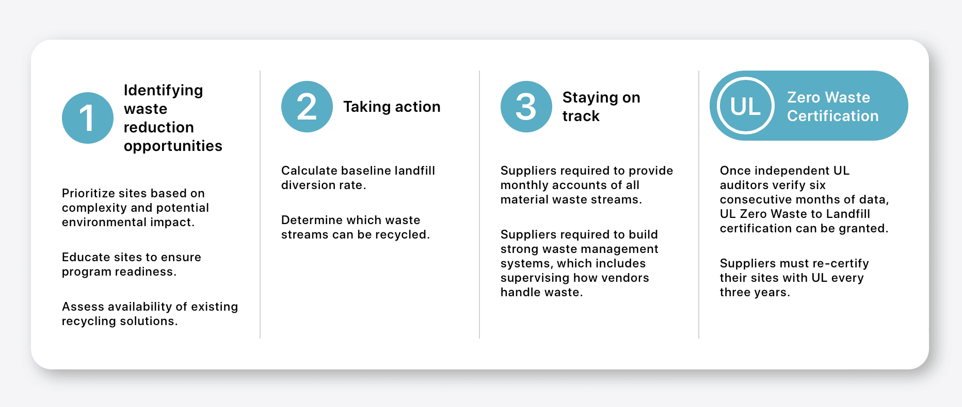
    - Max Columns: The maximum number of tiles that will be displayed horizontally before wrapping.
    - Wrap Columns: Either wraps tiles after the max columns has been reached, or displays carousel controls when set not to wrap.
  - One to Four Column:
    - Section Style:
      - Body Text: Styled for body text like seen at the top of each focus area page.
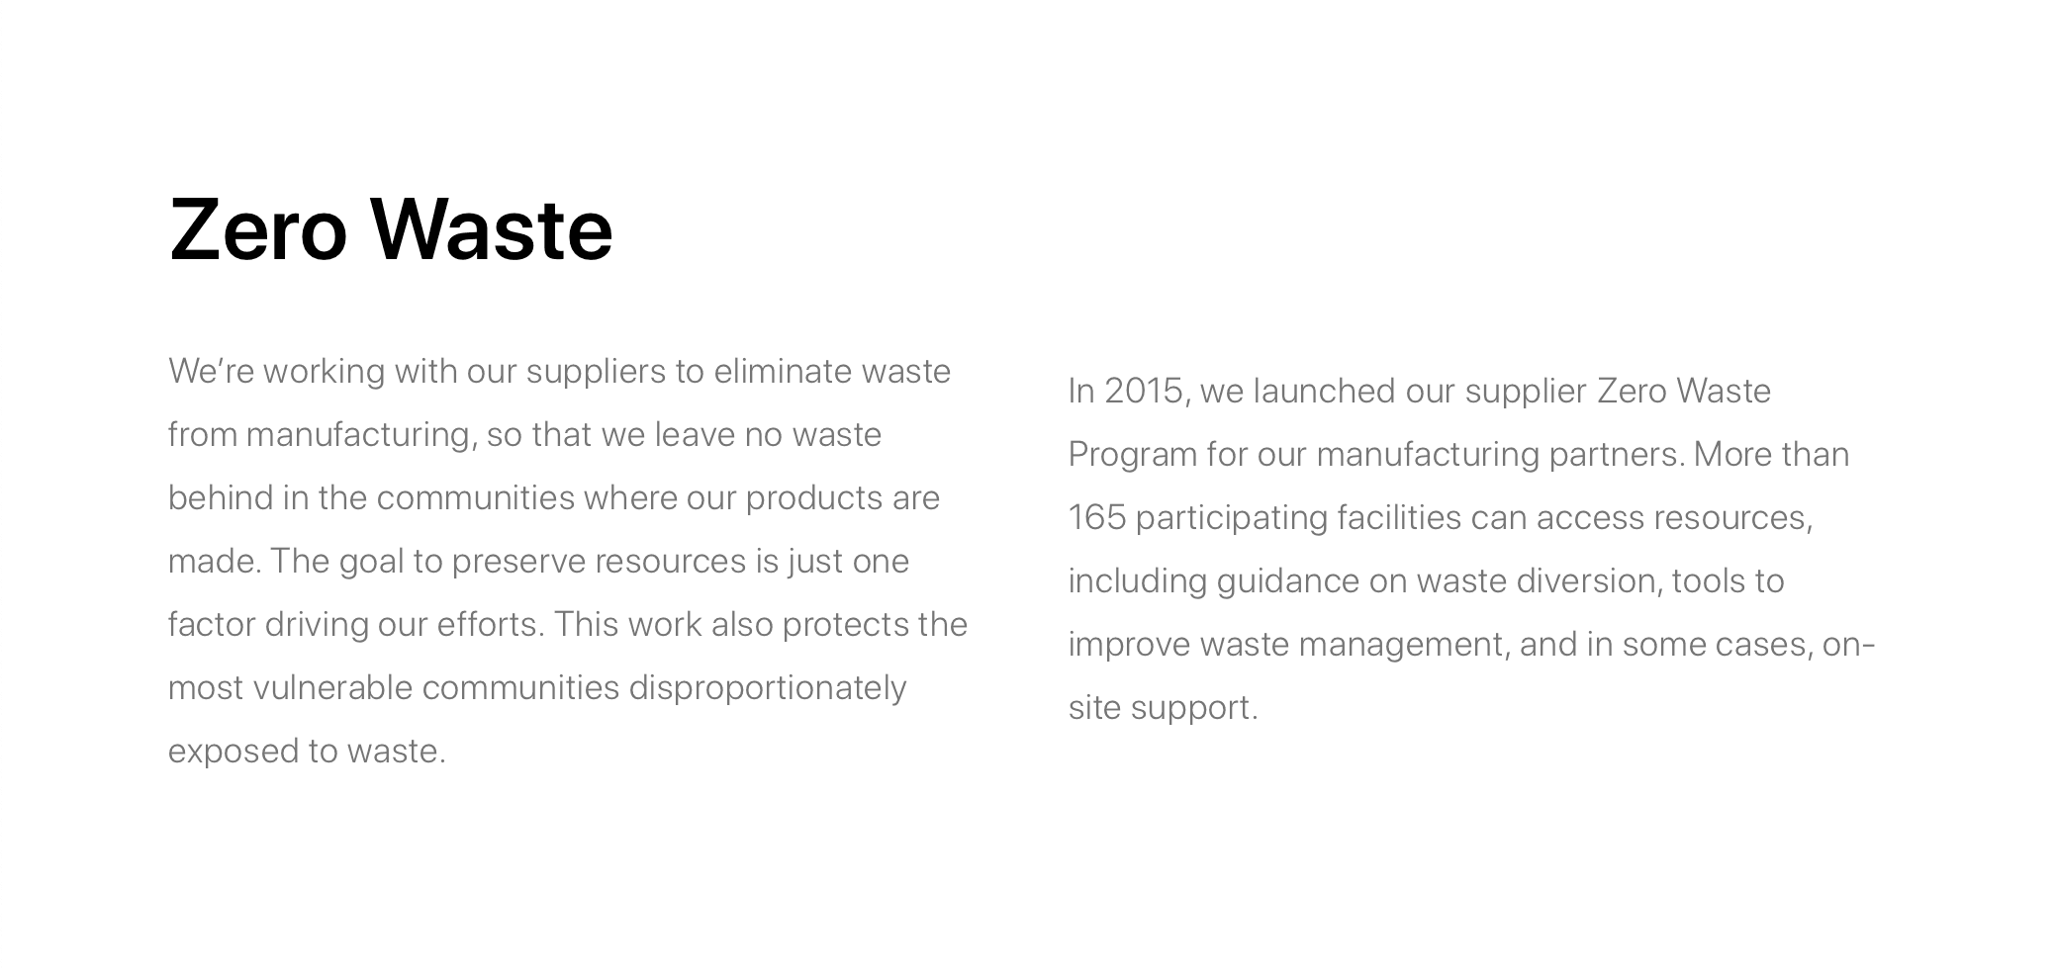
      - Icon/Text Columns: Columns with icon on the left and text on the right.
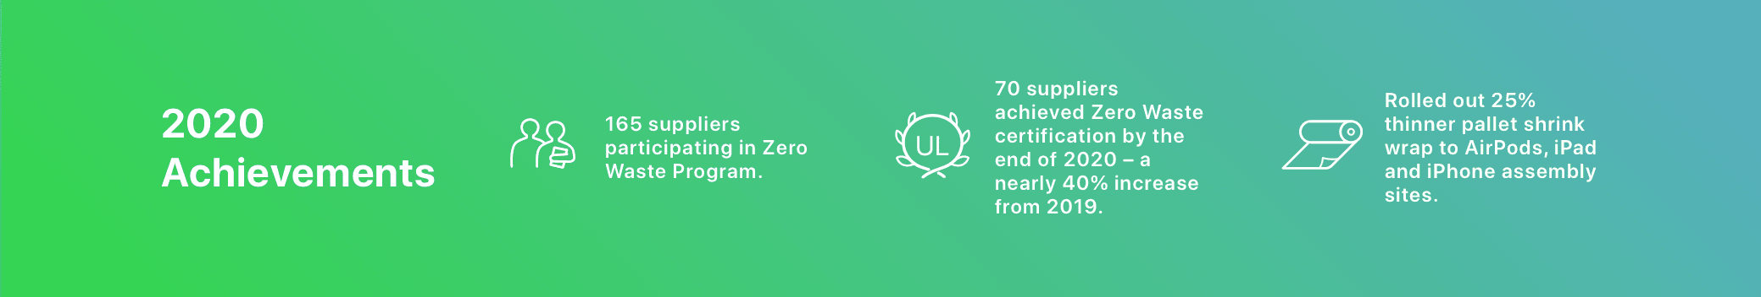
      - Image/Text Rows: Alternating rows with an image on one side and text on the other.
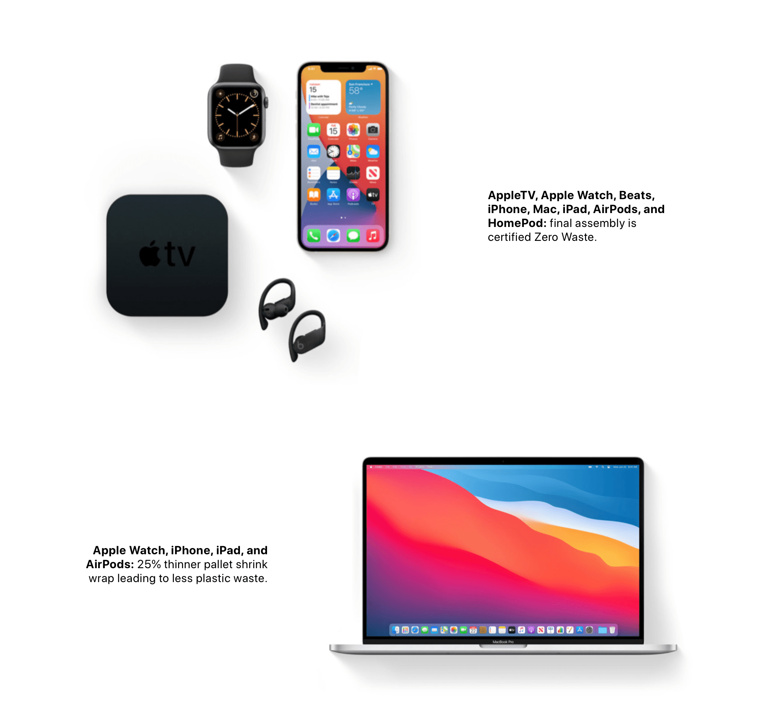
      - Image Centered / (padded): Centers an image horizontally in the row, without vertical padding against the rows above/below when a seamless look is desired, or with padding when the (padded) version is selected.
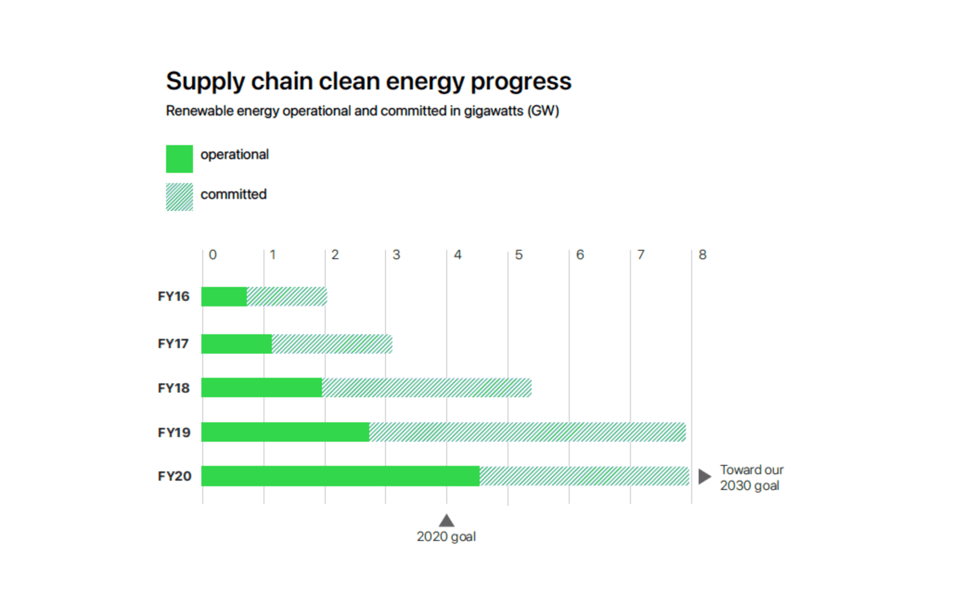
      - Learn More/Resources: Lozenge button lists like at the bottom of each focus area page.
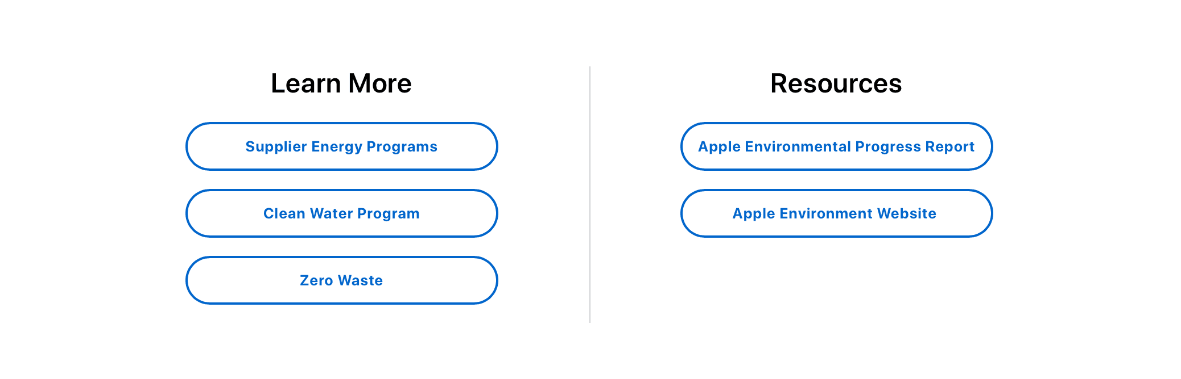
- Blocks:
  - General: These settings apply to several blocks:
    - Body: A text editor that allows freeform text, and some media, styling and formatting. The options available depend on the Text format selected at the bottom of the text editor. Most of the options should be familiar, but here are details about ones that have specific functions for this site:
      - Basic HTML: Provides options that meet most needs. If you find something you can’t do, select Full HTML instead for more options.
      - Full HTML: Provides more advanced general options, including the option to select text, click the DIV Icon, and select Two Columns to make a dual column text block that automatically flows between the columns.
      - Hero HTML: Provides styles specific to text for hero rows.
      - Tile HTML: Provides styles specific to tiles.
      - Link Icon: Allows creation of links to internal pages via autocomplete, or external pages from a full URL. Make sure to expand the Advanced link and check Open in a new window/tab for all external links.
      - Media Icon: Can add images or icons inline with text. An Edit Media button will be available after media is added to the editor where you can set additional options.
  - ESCI Hero:
    - Background Media: Used to select an image or video background for a hero row. Launches the media library where you can upload new media, or select from previously uploaded media.
    - Button Label: Adds a styled button with the label provided.
    - Button Icon: Adds an icon to the button from a predefined list of icons, currently only play or envelope.
    - Button Link: Where the button should go when clicked.
  - ESCI Tile:
    - Tile Image: Used to select the image for image tiles.
    - Tile Link: Where the tile should go when clicked.

When you are done editing the entire layout, but sure to click the Save layout button at the top left of the page. If you forget that step, you edits will still be saved, but will not be live on the page yet. To take all previous edits live, go back to the Layout and then click Save layout.

Adding New Pages
The following steps will allow you add, remove, or modify the menu and footer:
- Use the Drupal Admin Toolbar, and select Content > Add content > Basic page.
- Give the page an administrative Title the identify the page within the Drupal administrative UI.
- Click Save.
- Proceed editing the page with the Layout builder.
- Make sure to add the page to the menu and footer.

Updating the Site Menu
The following steps will allow you add, remove, or modify the menu and footer:
- Use the Drupal Admin Toolbar, and select Structure > Menus > Site Menu.
- Grab the Arrow Icons to reorder the menu structure with drag and drop.
- Click the Edit link in the row for the item you want to update, or click the Add link to add a new menu item.
- On the edit page, update the Menu link title field to change the text displayed in the menu.
- Update the Link field to change where the menu item will link to. The field will autocomplete for pages in the site while typing, or you can also put in a full https:// address.
- Click the Save button at the bottom of the page to save the changes.
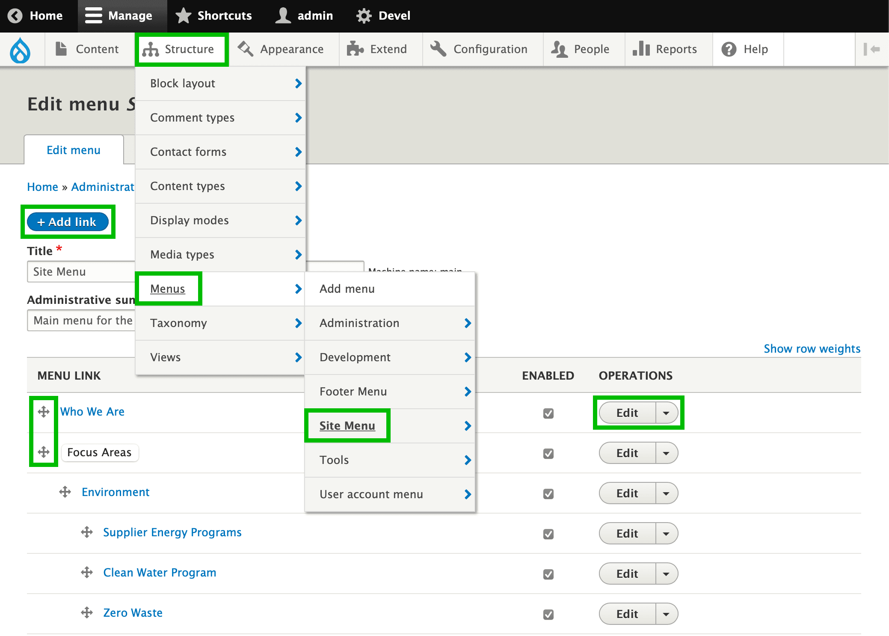
The same edits needs to be completed for the footer, which can be accessed from Structure > Menus > Footer Menu.

Migrating Changes from UAT to Production
It is recommended to do all editing on the UAT site until everything is as it should be, and then migrate changes to production once approved. The process involves exporting the database and files from UAT and then importing them into Production:
- On UAT, use the Drupal Admin Toolbar, and select Configuration > Development > Backup and Migrate.
- Select Default Drupal Database as the Backup Source.
- Click Backup now, which will save a copy of the database to your machine, likely in the downloads folder.
- If you have added or changed any media files, also export those by choosing Public Files Directory as the Backup Source, and clicking Backup now again.
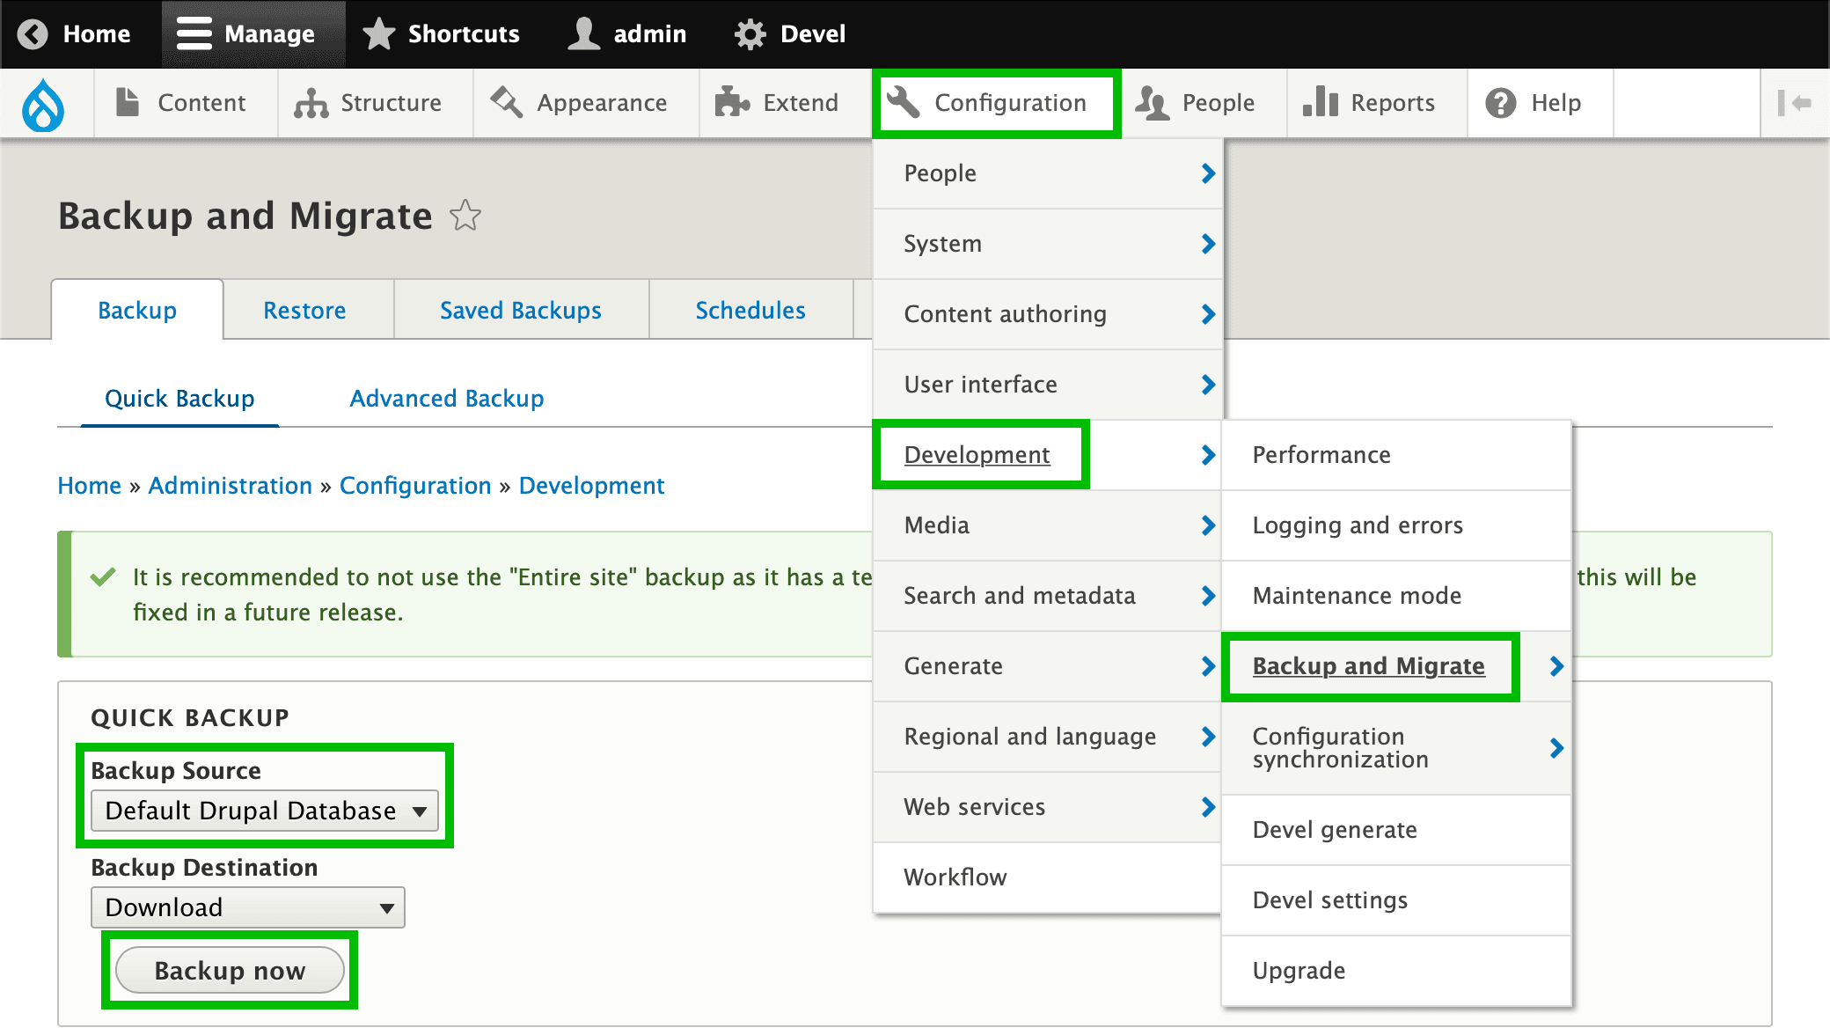
- On Production, use the Drupal Admin Toolbar, and select Configuration > Development > Backup and Migrate > Restore.
- Under Upload a Backup File, choose the database file you exported from UAT, likely in your downloads folder.
- Select Default Drupal Database as the Restore To.
- Click Restore now.
- If you have added or changed any media files, also import those by choosing Public Files Directory as the Restore To, and clicking Restore now again.
- After all imports are done, clear the site cache with the Drupal Admin Toolbar, and select the Drupal Icon > Flush all caches.
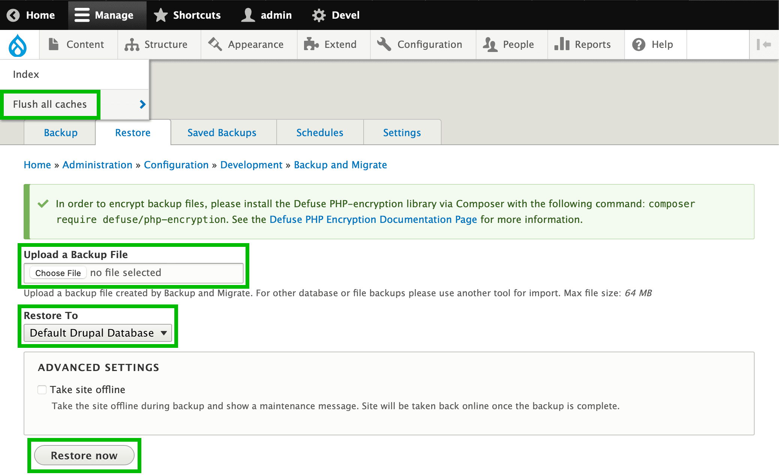

Design Media Assistance
If you have any questions about these instructions or need assistance with any other SRWeb modification or maintenance task, please contact Design Media.
- Scot Muncaster (415) 641-4848, Ext.177 smuncaster@designmedia.com
- David Brown (415) 641-4848, Ext.157 dbrown@designmedia.com

Apple ESCI Website Analytics
Quick Reference Guide

Overview
The SRWeb website analytics are tracked by Matomo. This document details the basics for logging into and viewing the ESCI website analytics. More comprehensive documentation on how to use Matomo can be viewed at https://matomo.org/help.

Login
Log into Matomo to view the analytics:
- Go to https://esci.apple.com/analytics/matomo.
- Username: apple_admin
- Password: ESCI-admin-!976

Dashboard
A dashboard has been set up with a few key metrics that may be of interest. Page Titles shows metrics for each page. Visits Over Time shows traffic levels over time. Both of these display metrics based on the time period selected at the top of the dashboard. Change the time period to see metrics over a different period.

